

Placement Empowerment Program
Cloud Computing and DevOps Centre

Use Cloud Storage
Create a storage bucket on your cloud platform and upload/download files.
Configure access permissions for the bucket

Name: Harshana Perianayaki B Department : IT



INTRODUCTION
Cloud storage in Microsoft Azure is managed using Azure Blob Storage within Azure Storage Accounts. It allows users to store, manage, and retrieve files securely. In this guide, we will create a storage bucket (container), upload and download files, and configure access permissions to control data security.

OBJECTIVES
- Learn how to create an Azure Storage Account.
- Set up a Blob Storage Container for file storage.
- Upload and download files using Azure Portal, CLI, or SDKs.
- Configure access permissions for public and private access.

OVERVIEW
Azure Blob Storage is designed to handle unstructured data, such as documents, images, videos, and backups. The process includes:
- Creating a Storage Account (where data is stored).
- Creating a Blob Container (similar to a storage bucket).
- Uploading and downloading files using Azure Portal, Azure CLI, or PowerShell.
- Configuring access permissions to control file visibility and security.

IMPORTANCE OF GIT BRANCHING
✅ Scalability – Store and retrieve data efficiently.
✅ Security – Control access with IAM roles, SAS tokens, or Shared Keys.
✅ Cost-Effective – Pay only for the storage used.
✅ Integration – Works seamlessly with Azure VMs, Functions, and other services.
✅ Backup & Disaster Recovery – Ensures data is securely backed up.

STEP-BY-STEP OVERVIEW

Step 1: Create a Storage Account
- Go to Azure Portal

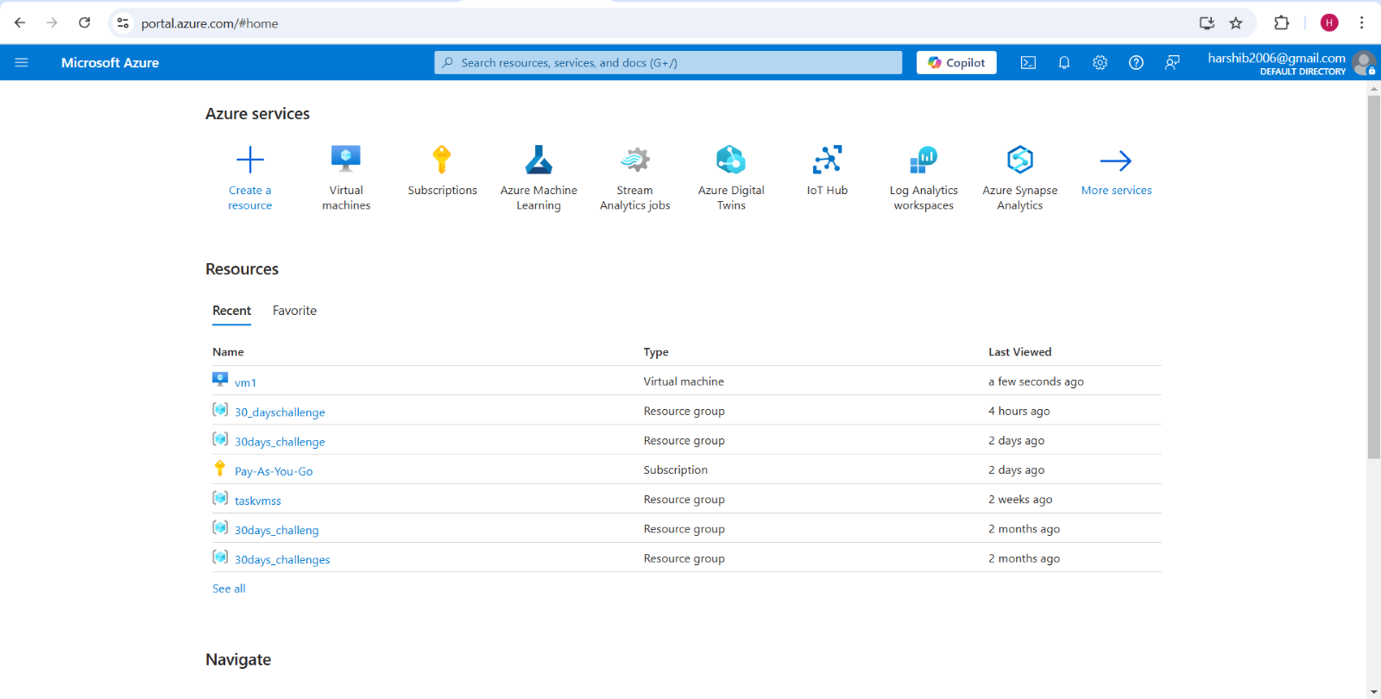

- Navigate to Storage Accounts:
  - Click Create a resource → Storage Account.

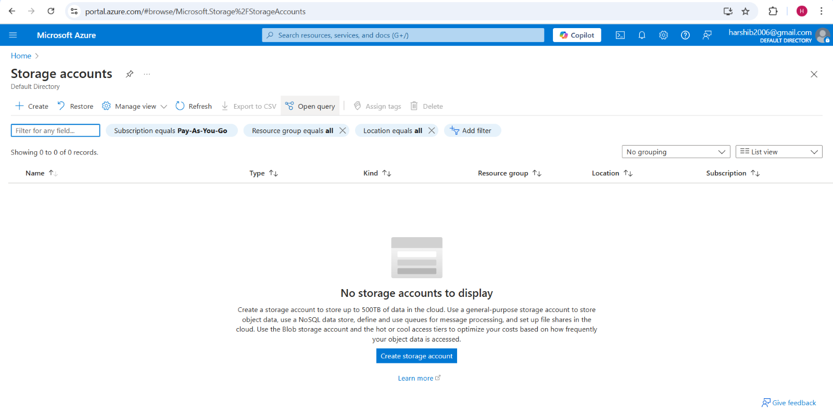
- Configure the Storage Account:
  - Subscription: Select your Azure subscription.
  - Resource Group: Choose or create a new resource group.
  - Storage Account Name: (e.g., mystorage123).
  - Region: Choose a location (e.g., East US).
  - Performance: Standard (default) or Premium.
  - Replication: LRS (Local Redundant Storage) for basic redundancy.

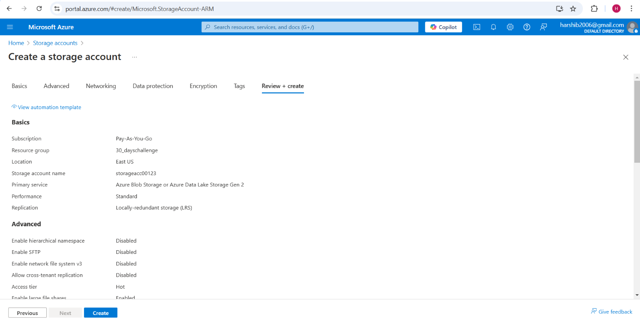
- Click Review + Create → Create.

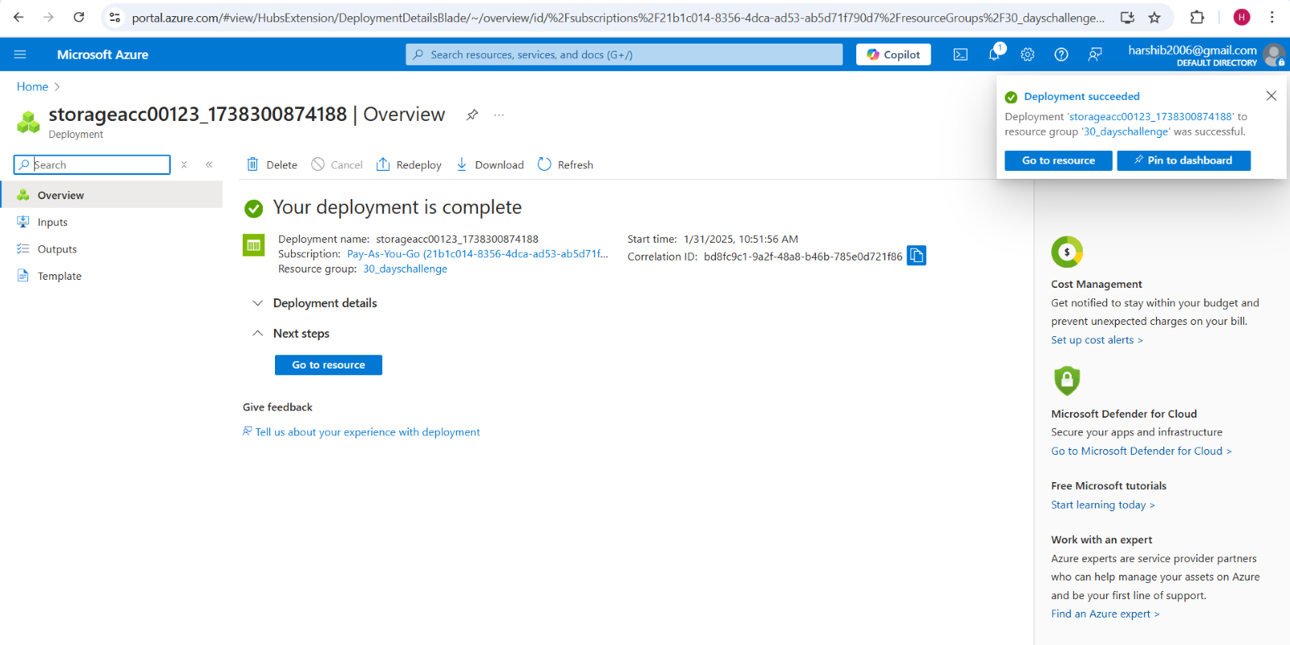

Step 2: Create a Blob Storage Container
- Open your Storage Account in the Azure Portal.

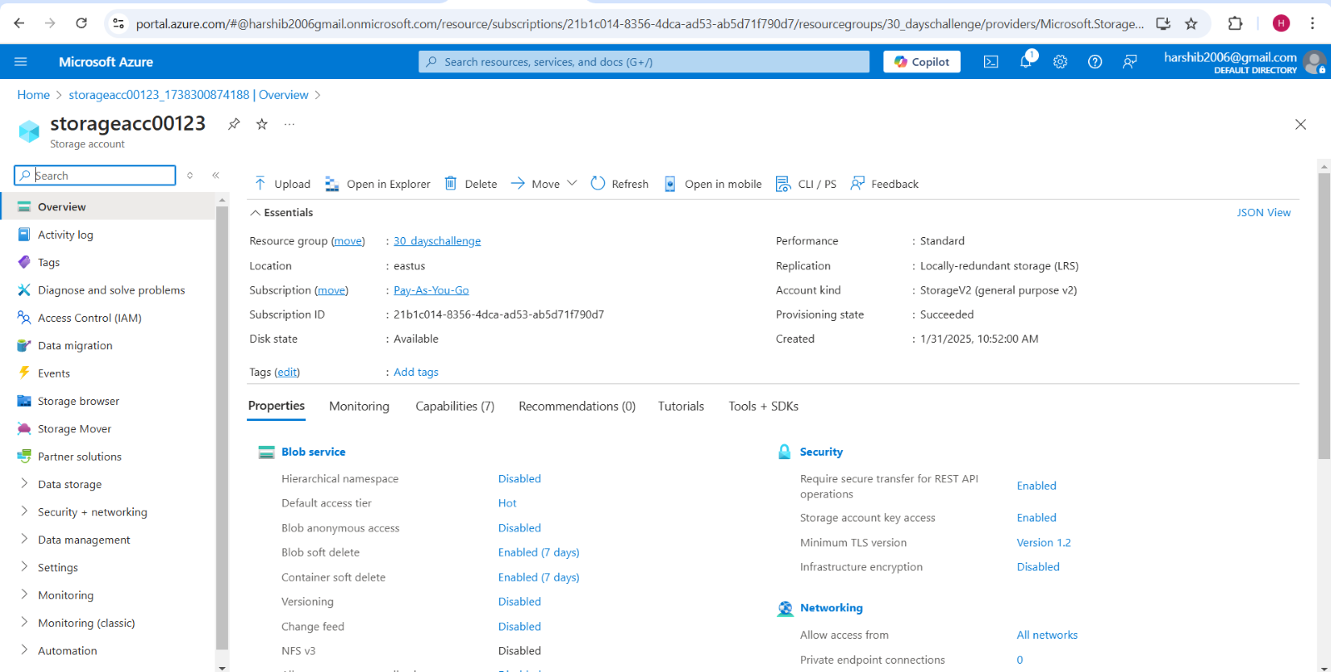
- Navigate to Containers → Click + Container.

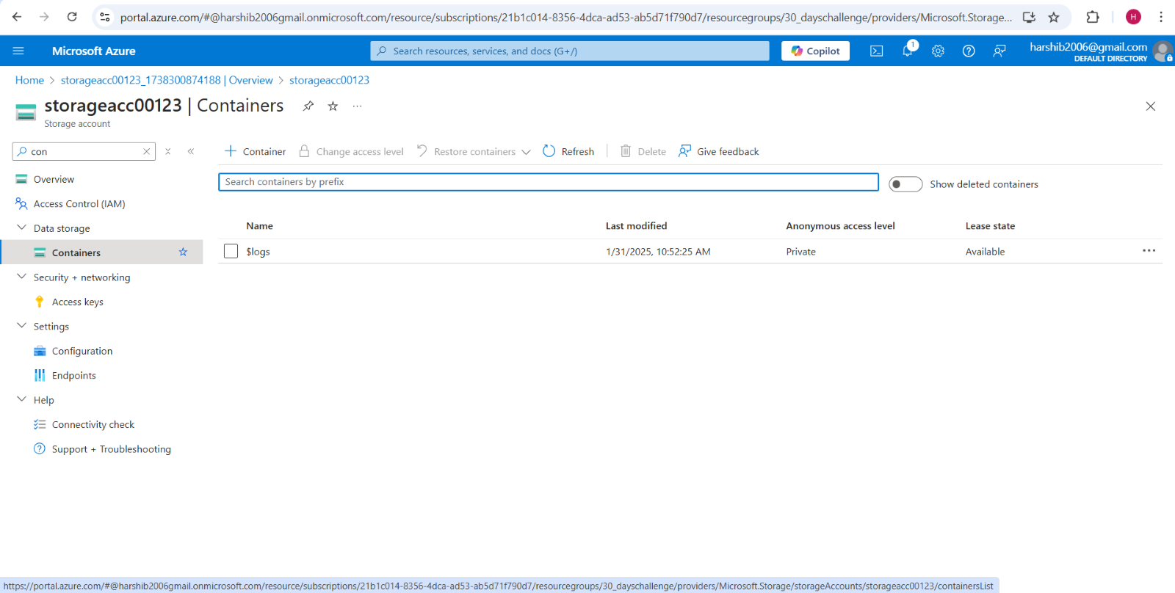
- Enter a name (e.g., mycontainer).

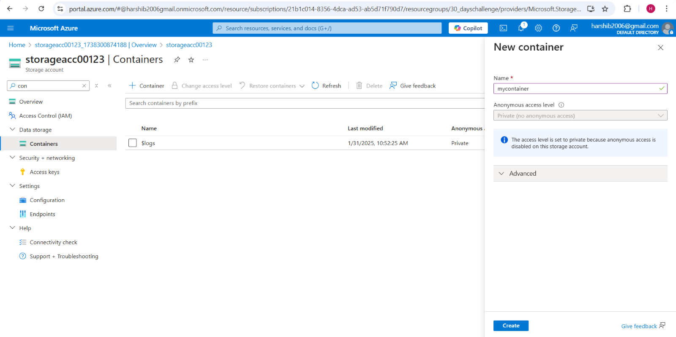
- Set Access Level:
  - Private (default) – Only authorized users can access.
  - Blob – Public read access to files only.
  - Container – Public read access to entire container.
- Click Create.

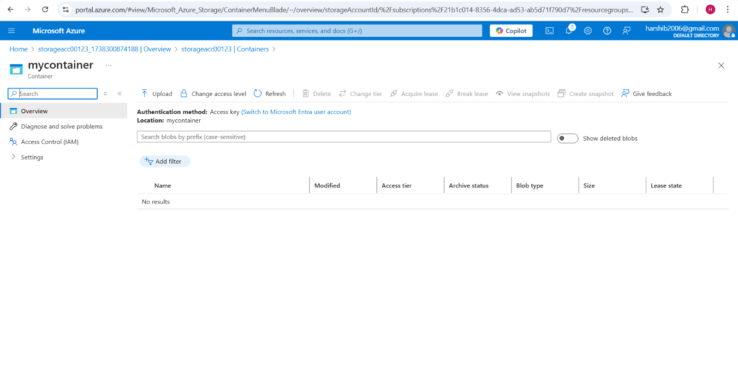

Step 3: Upload and Download Files

Using Azure Portal
- Go to your Container.
- Click Upload → Select a file from your system → Click Upload.

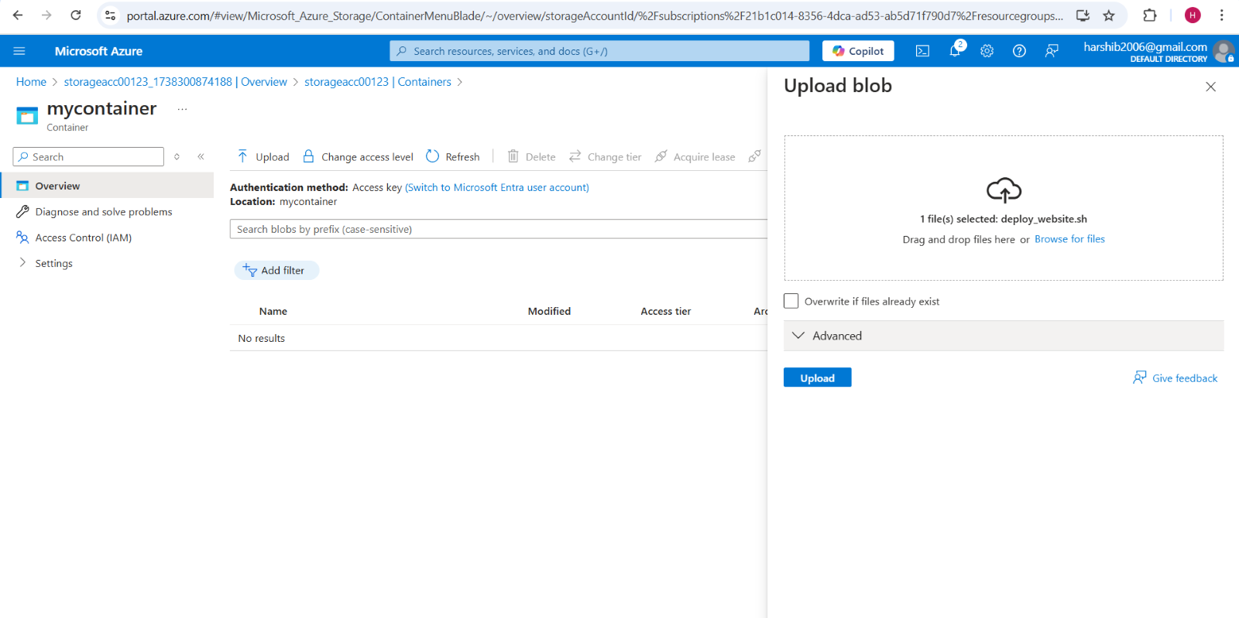
- To download, select the file → Click Download.

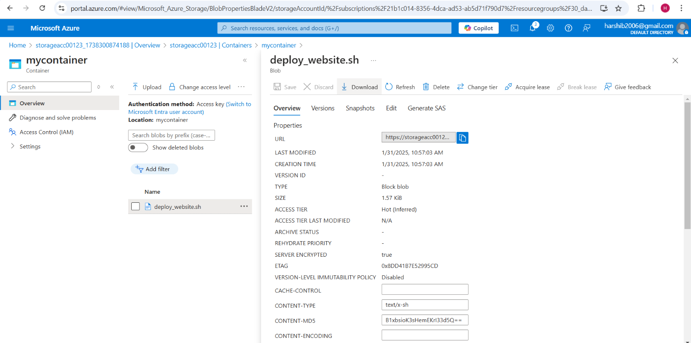

Using Azure CLI

Upload a File
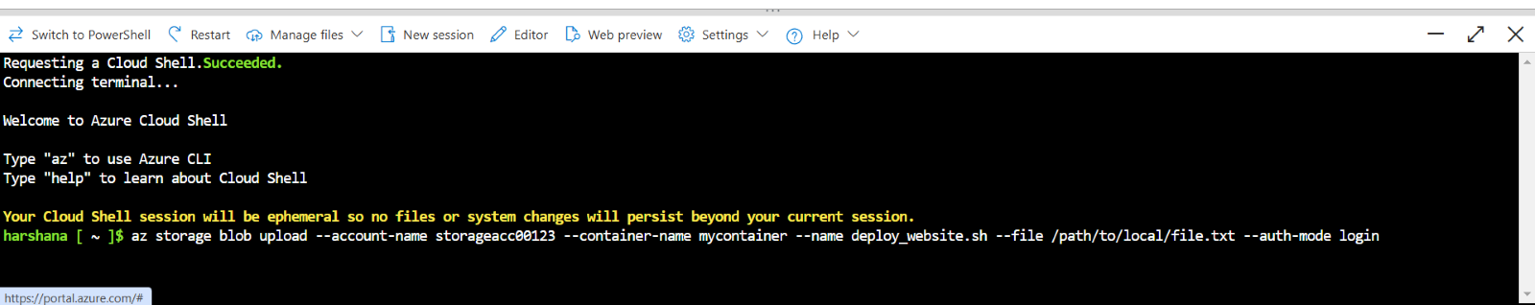

Download a File
Step 4: Configure Access Permissions
Option 1: Using Shared Access Signature (SAS)
Go to Storage Account → Shared Access Signature.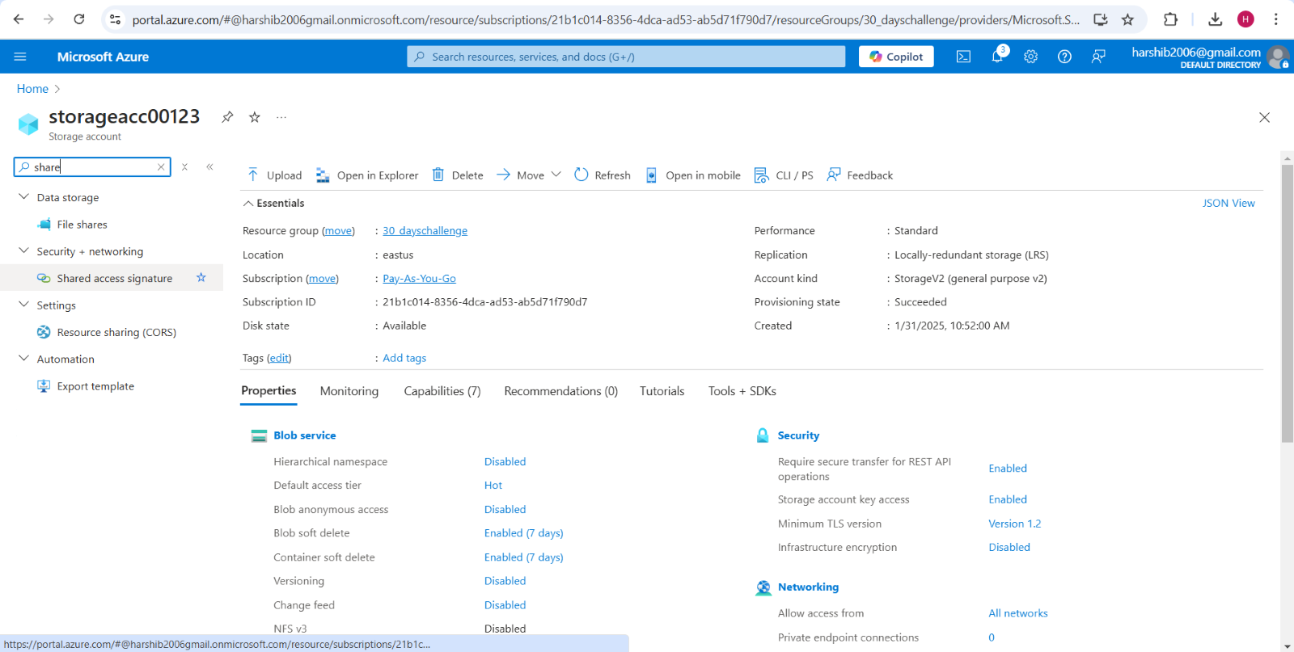
- Select Permissions (Read, Write, Delete, etc.).

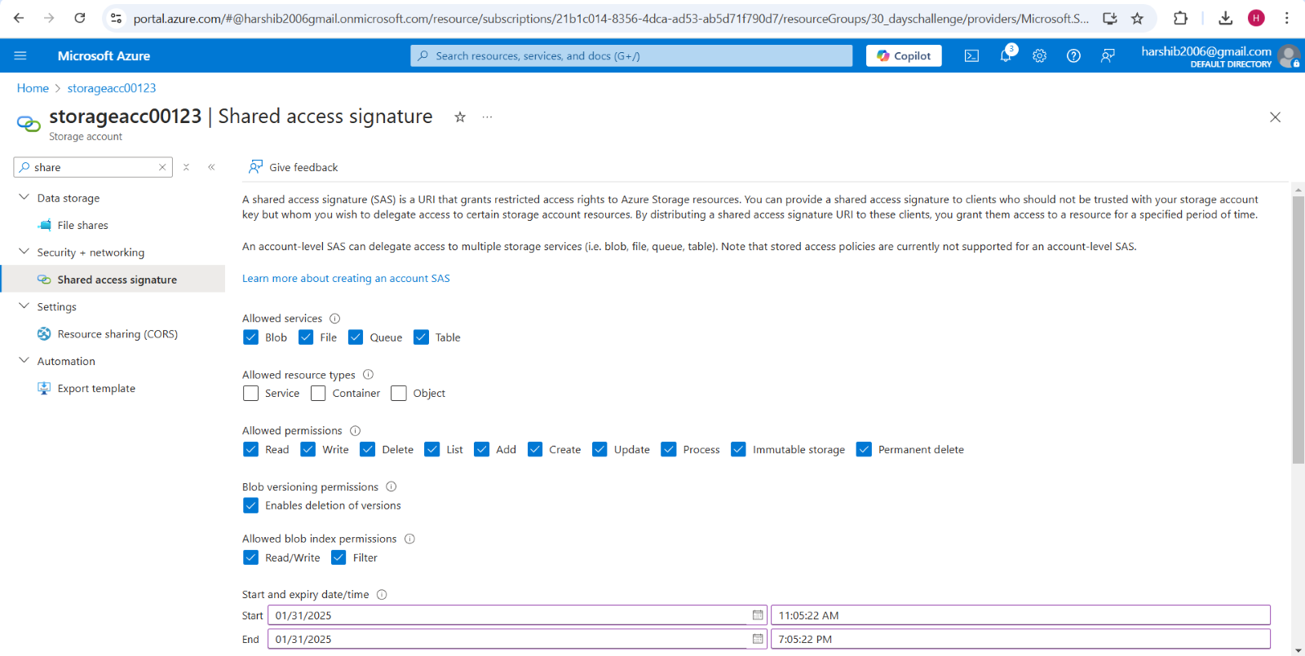
- Set an Expiration Date and IP Restrictions.

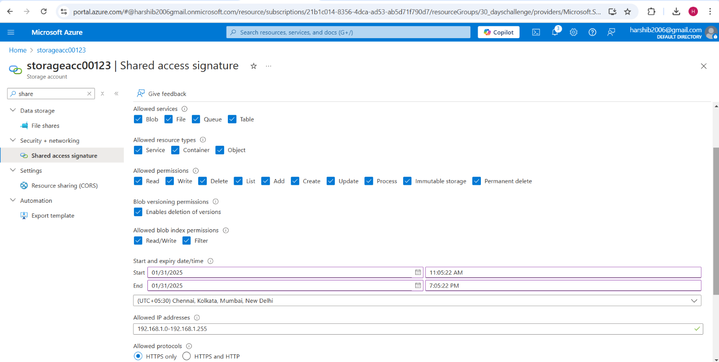
- Click Generate SAS Token and URL → Copy the Blob SAS URL to share access securely.

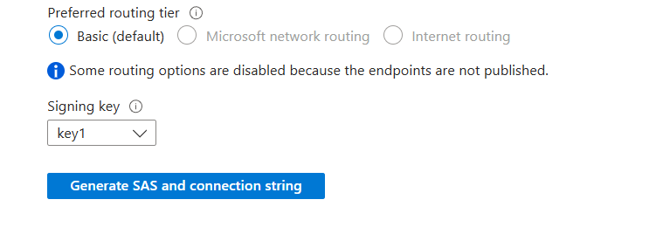
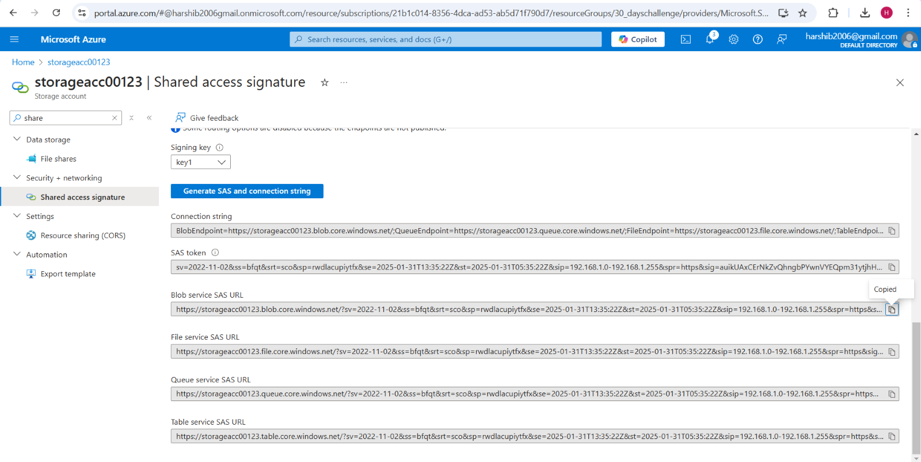

Option 2: Using Role-Based Access Control (RBAC)
- Go to Storage Account → Access Control (IAM).

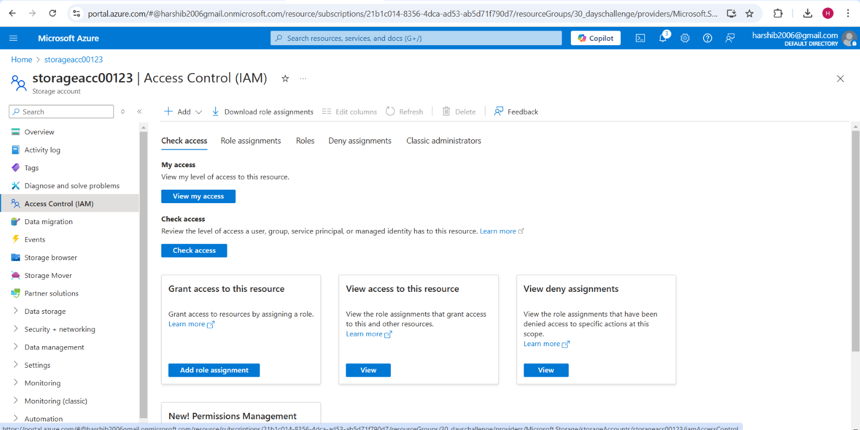
- Click Add Role Assignment → Select:
  - Storage Blob Data Contributor (Read/Write).
  - Storage Blob Data Reader (Read-only).
  - Storage Blob Data Owner (Full Control).

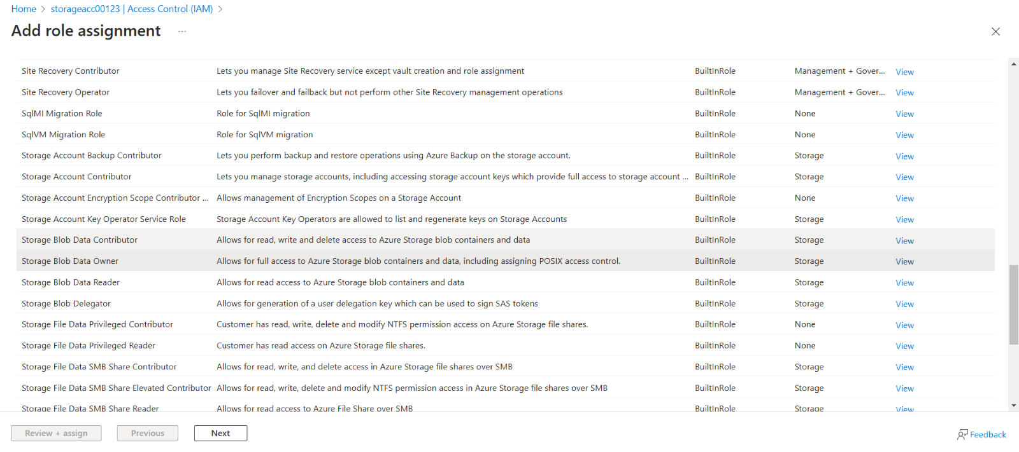
- Assign it to a user, group, or managed identity.

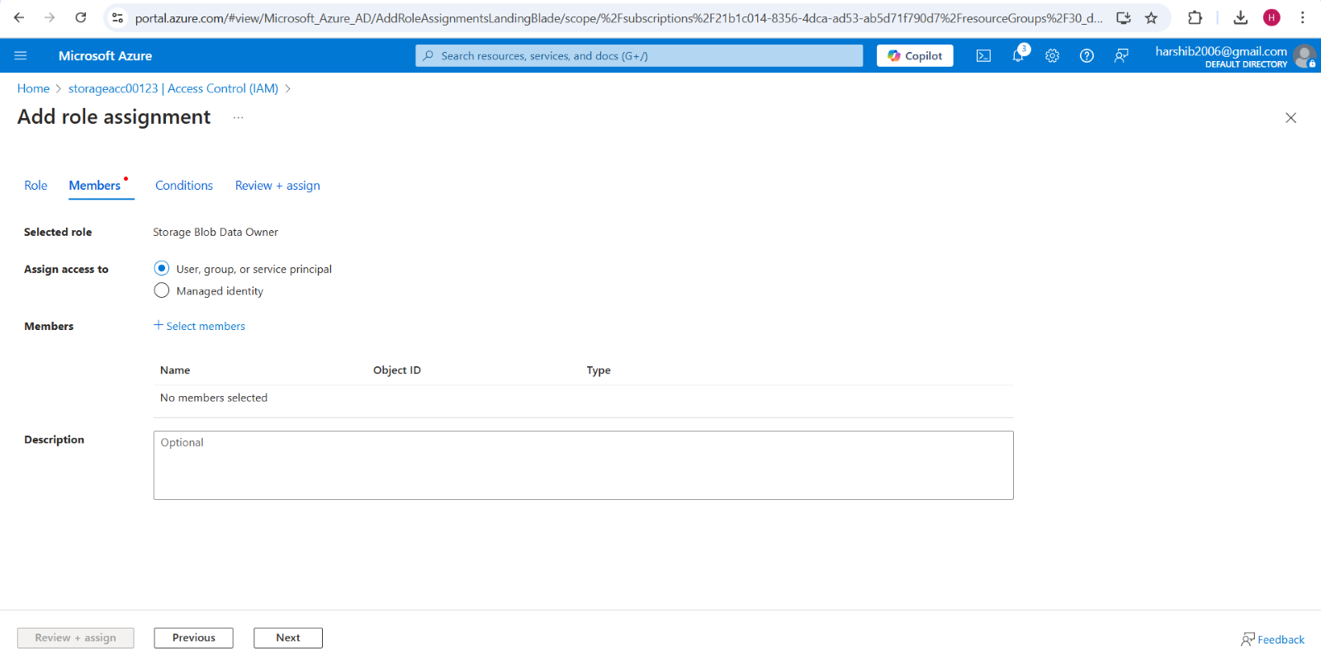

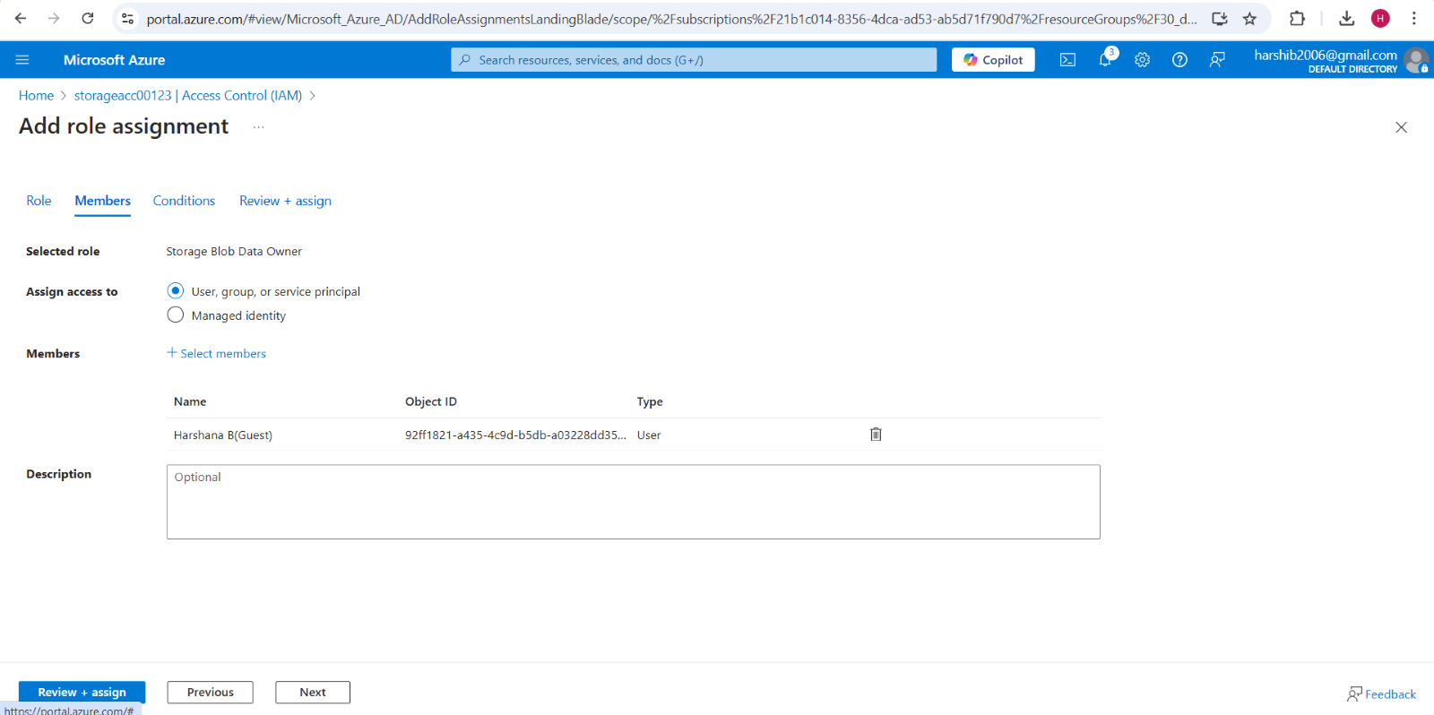
- Click Review + Assign.

OUTCOME
✅ A storage bucket (container) is created in Azure.
✅ Files can be uploaded and downloaded securely.
✅ Access permissions are configured to protect sensitive data.
✅ Users can access storage securely using IAM roles or SAS tokens.

